# Image Processor LLD

## Components

The following components constitute this image processor service which compress quality of images provided in a csv file

1. WSGI – This is the web server which integrates with the flask server and handles the incoming requests and assign workers to achieve multiple request handling
2. Flask Application – This is the core application which servers the core business logic
3. Cloud File Storage – This is the service which uploads an image to a cloud platform (cloudinary) here and generates a unique URI to access the resource
4. Cloud Database – This is the database where all the data and meta data is stored in SQL relations

## Database Schema

In the system there is a database named **public** (make sure to create it before running the application) and it has following tables

1. image_processor_request
2. webhook_subscription

Schema for image_processor_request

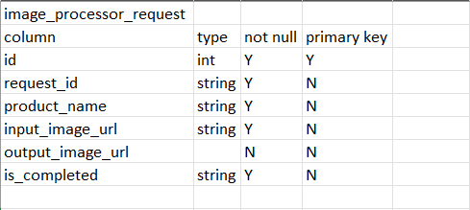

Schema for webhook_subscription



## Architecture

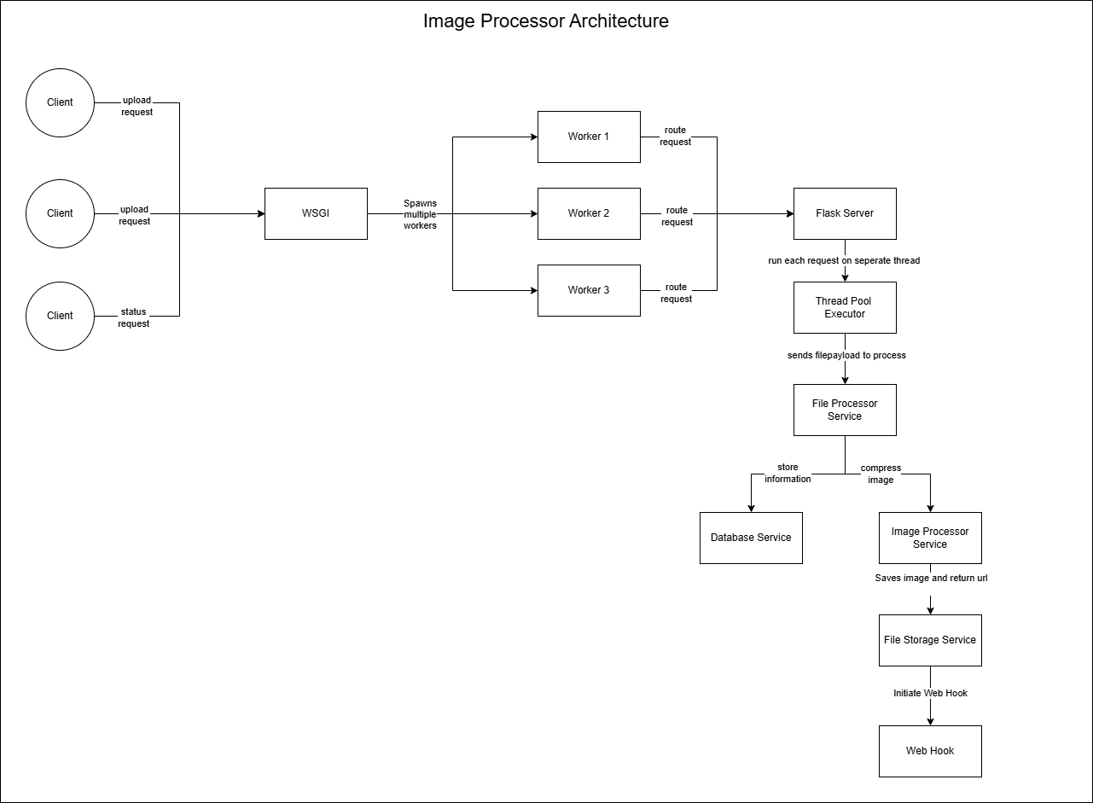

## Services

1. Request Processor Service: In this service we handle each request with their product name and image URL. This service calls many other services and is core responsible of processing requests.   
   Task of this service
   1. Get the image payload from the endpoint provided in the input.csv
   2. Call other needed services to do further actions
2. Image Processor Service: In this service we compress the image with a ratio called compression ratio   
   Task of this service
   1. Compress an image payload by given compress ratio
3. File Processor Service: In this service we process the input csv we receive and apply validations and return the data of csv in a dictionary   
   Task of this service
   1. Read input csv
   2. Apply validations
   3. Return data of csv in a suitable format
4. File Storage Service: In this service we upload the compressed image to a cloud storage   
   Task of the service
   1. Upload image to a cloud resource
   2. Return access URL of resource
5. Database Service: This service interacts with database   
   Task of the service
   1. Create a connection pool
   2. Add a new request information
   3. Update previous request information
   4. Fetch request Information
   5. Add webhook subscription information
6. Web Hook Service: This service triggers an event on the webhook upon request completion Task of the service
   1. Call web hook endpoint on request completion

## Appendix

To run the application set up cloudinary credentials by creating a free cloudinary account [here](https://cloudinary.com/users/register_free)

Application is hosted at (refer API documentation to before using it):

https://imageprocessor-8qgh.onrender.com

## 